3.6: a) , so and
.
b) 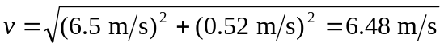, at an angle of 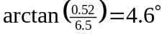 above the horizontal.
c)
